Angular

## ngFor with Add and Remove

1. We can allow the user to add new records(objects) to the existing array. The user can also delete existing records
2. We use “push” function to add new object to array
3. We can “splice” function to remove existing objects from the array

Syntax:

arrayVariable.push(value);

arrayName.splice(index,count);

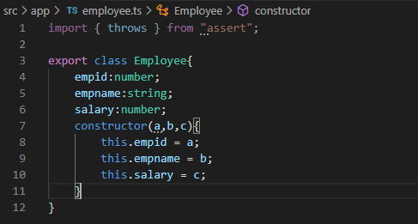

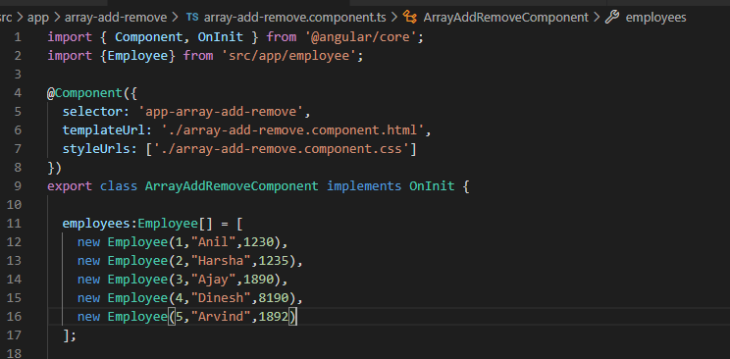

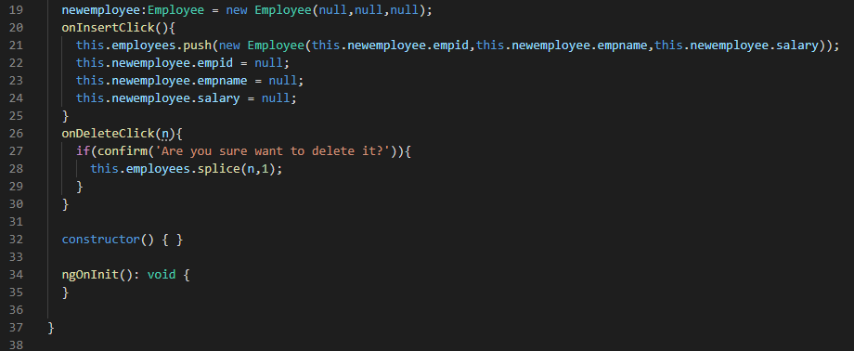

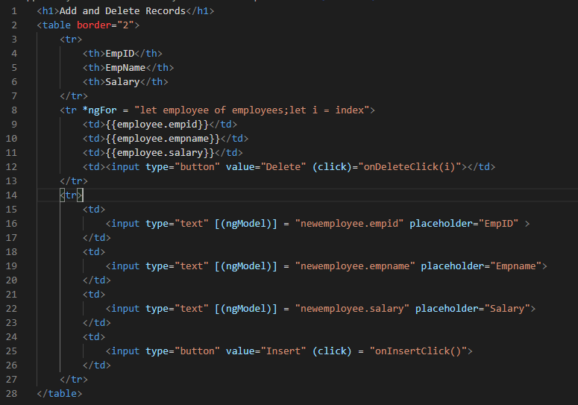

## ngFor with Searching and Sorting:

1. We can “filter” functions to search content. The filter function receives a callback function, which gets executed once for each item in the array. In the sequence if the callback function returns “true” the item will be kept, if it returns “false” then the item will be skipped.
2. We can “sort” to sort the data of the given array

Searching Syntax:

arrayname.filter(item) =>{return true or false;});

Sorting Syntax:

arrayname,sort(

(item1,item2) = >

{

if(item is less then item2)

return -1;

else if(item1 > item2)

return 1;

else

return 0

}

}

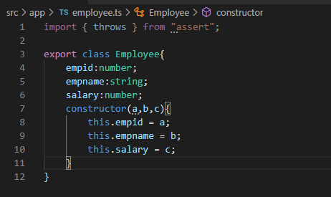

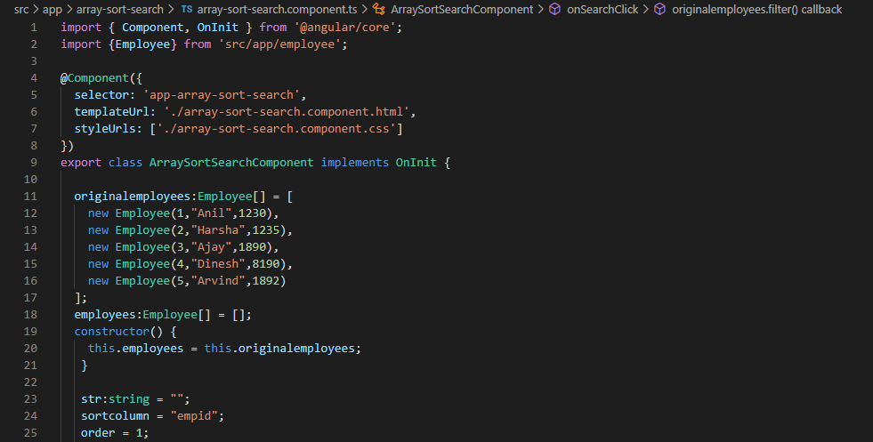

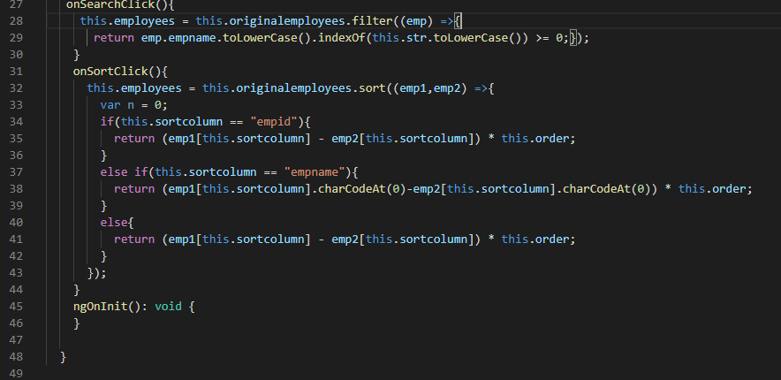

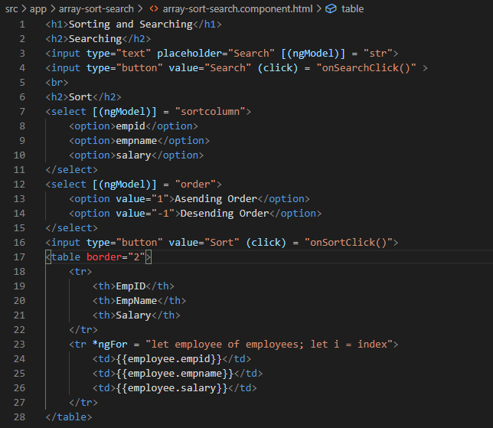

## Assignments:

1. Login page Connect with MySQL Database
2. Registration page connect with MySQL Database
3. Home Page - You need list all the employees
   1. Sort
   2. Search
   3. Add new record
   4. Delete existing record

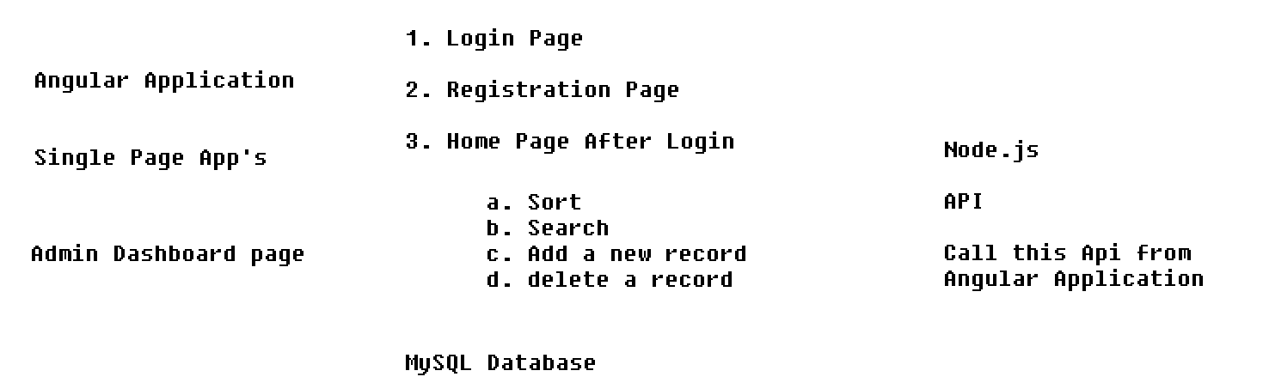

## Multiple Components

1. We can create any number of components as an Angular Application. The component represents a specific section in the web page. The component is a class with properties and methods.
2. At root level, only one component is should be there, which is called as “**AppComponent**” and all other components are called as **Child Components**
3. We can use the child component selector to invoke the child component in the parent component